**SMART TWO WHEELER INTELLIGENT RETROFIT KIT SYSTEM**

## A PROJECT REPORT

***Submitted by***

**ARAVIND . R 211419105011**

**ARUN KUMAR . B 211419105014**

**GOKULKRISHNAN . J 211419105038**

**JONATHAN DERYK . A 211419105057**

***in partial fulfilment for the award of the degree***

***of***

**BACHELOR OF ENGINEERING**

***in***

## ELECTRICAL AND ELECTRONICS ENGINEERING



**PANIMALAR ENGINEERING COLLEGE**

**(An Autonomous Institution, Affiliated to Anna University, Chennai)**

**APRIL 2023**

## PANIMALAR ENGINEERING COLLEGE

**(An Autonomous Institution, Affiliated to Anna University, Chennai)**

**BONAFIDE CERTIFICATE**

Certified that this project report **“ SMART TWO WHEELER INTELLIGENT RETROFIT KIT SYSTEM ”** is the bonafide work of **“ ARUN KUMAR . B (211419105014), ARAVIND . R** **(211419105011), GOKULKRISHNAN . J (211419105038), JONATHAN DERYK . A** **(211419105057) ”** who carried out the project work under my supervision .

|  |  |
| --- | --- |
| **SIGNATURE** | **SIGNATURE** |
| **Dr . S . SELVI, M . E, Ph . D .** | **Dr . N . MANOJ KUMAR, M . E, Ph . D .** |
| **HEAD OF THE DEPARTMENT** | **SUPERVISOR** |
| **PROFESSOR** | **PROFESSOR** |
| Department of Electrical and | Department of Electrical and |
| Electronics Engineering, | Electronics Engineering, |
| Panimalar Engineering College, | Panimalar Engineering College, |
| Chennai-600 123 | Chennai-600 123 |

Submitted for End Semester Project Viva Voce held on …………………… at Panimalar Engineering College, Chennai **.**

**INTERNAL EXAMINER EXTERNAL EXAMINER**

**ACKNOWLEDGEMENT**

Our sincere thanks to our Honourable Founder and Chairman, **Dr . JEPPIAAR,M . A . ,B . L . ,Ph . D . ,** for his sincere endeavour in educating us in his premier institution .

We would like to express our deep gratitude to our beloved **Secretary and Correspondent, Dr . P . CHINNADURAI, M . A . ,M . Phil . ,Ph . D** for his enthusiastic motivation which inspired us a lot in completing this project and our sincere thanks to our Directors **Mrs . C . VIJAYA RAJESWARI, Dr . C . SAKTHI KUMAR, M . E . ,Ph . D**  and **Dr . SARANYASREE SAKTHIKUMAR,B . E,M . B . A,Ph . D** for providing us with the necessary facilities for the completion of this project .

We would like to express thanks to our Principal, **Dr . K . MANI M . E . , Ph . D . ,** for having extended his guidance and cooperation .

We would also like to thank our **Head of the Department**, **Dr . S . SELVI, M . E . , Ph . D . , Professor and Head, Department of Electrical and Electronics Engineering** for her encouragement .

Personally, we thank our Guide **Dr . N . MANOJ KUMAR,M . E . ,Ph . D . , in Department of Electrical and Electronics engineering** for the persistent motivation and support for this project, who at all times was the mentor of germination of the project from a small idea .

We express our sincere thanks to the project coordinators **Dr . S . DEEPA** **&** **Dr . N . MANOJ KUMAR,M . E . ,Ph . D . , in Department of Electrical and Electronics Engineering** for the Valuable suggestions from time to time at every stage of our project .

Finally, we would like to take this opportunity to thank our family members, faculty and non-teaching staff members of our department, friends, well-wishers who have helped us for the successful completion of our project .

# ABSTRACT

This project describes the need for ease and enhancement of the quality of security systems owned by motorcycles has encouraged manufacturers to produce sophisticated security systems . It aims to reduce the action of criminality that often occurs on motorcycles . One of them is keyless lock ignition locking system .

The keyless ignition system is a key module that has an RF transmitter to transmit data to an RF receiver module on a motorcycle . The device allows the exchange of data can occur within a certain radius . This aims to facilitate the owner of a motorcycle in the opening or lock and turn on or turn off his motorcycle without a key . Because automatically within a certain radius, the motorcycle can be opened by turning the ignition switch only . The keyless ignition locking system also has a unique encryption pattern between the modules . So that if there are two different motorcycles though the same type, there will not happen the error of data transferring .

From 30 times testing lock and unlock the keyless motorcycle . And turn on and turn off the motorcycle . This keyless ignition system can work properly . The percentage obtained in testing turned on a motorcycle at 83% .

### TABLE OF CONTENTS

**CHAPTER NO TITLE** **PAGE NO**

**ABSTRACT** i

**LIST OF TABLE** iii

**LIST OF FIGURE** iv

**LIST OF ABBREVIATIONS vi**

1. **INTRODUCTION** 1
   1. Smart Two Wheeler Intelligent Kit System 2

1. **LITERATURE SURVEY** 3

1. **EXISTING SYSTEM** 9

1. **PROPOSED SYSTEM** 12
   1. Intelligent Safety system 12
   2. Smart Navigation 13
   3. Integrated Connectivity 13
   4. Performance Optimization 13

4.5 Anti theft Protection 13

4.6 Overview 13

1. **FLOWCHART EXPLANATION 15**
2. **HARDWARE DESIGN** 17
   1. Voltage Regulator 17

6.1.1 Limitations Of Voltage regulator 18

6.1.2. Voltage Regulator Control 19

6.2 Remote Keyless System 20

6.3 Keyless Ignition System 24

6.4 RF Transceiver 27

6.4.1 The Working Principle Of RF Transceiver 28

6.4.2 Technical Specifications 28

6.4.3 RF-Based Home Automation System 30

6.5. ESP32 Dev Board 33

6.5.1 ESP32 Specification 35

6.5.2 ESP32 Development Boards 37

6.5.3 ESP32 DEVKIT 38

6.5.4 ESP32 DEVKIT V1 Pins PinOut 39

6.6 Relay 40

6.6.1 5V Relay Module Specifications 41

6.6.2 5V Relay Module Circuit 42

6.6.3 5V Relay Module Pinout 43

6.6.4 5V Relay Module Working 44

6.6.5 5V Relay Module For Arduino 45

6.7 Vibration Sensor 47

6.8 DC-DC Step Down Converter Module LM2596 48

6.8.1 Pin Configuration and Functions 50

6.8.2 Undervoltage Lockout For Inverting Regulator 52

6.8.3 4 Pin 12V relay 54

1. **CONCLUSION** 56

**REFERENCES** 57

**APPENDIX** 59

I . Code for the Prototype 59

# LIST OF FIGURES

#### FIGURE NO . NAME OF THE FIGURE PAGE NO

3 . 1 Schematics of the Keyless Ignition System 9

4 . 1 Schematics of the RF based Motorcycle Keyless 12

Ignition System

5 . 1 Flowchart Of Keyless Ignition System 15

5. 2 Block Diagram Of keyless Ignition System 16

6 . 1 Voltage Regulator 17

6 . 2 Remote Keyless System 20

6 . 3 Keyless Ignition System 24

6 . 4 Radio Frequency Transmission 27

6 . 5 ESP32 Dev Board 33

6 . 5 .2 ESP32 Development Board 35

6. 6 Relay 39

6 . 6 .2 5V Relay 41

6 . 6 .3 5V Relay Module PINOUT 42

6 . 7 Vibration Sensor 45

6 . 8 LM2596 DC-DC Step Down Converter 47

#### FIGURE NO . NAME OF THE FIGURE PAGE NO

6 . 8 . 1 Pin Configuration And Functions Of LM2596 48

6 . 9 12V 4 Pin Relay 52

### LIST OF ABBREVIATION

|  |  |  |  |  |
| --- | --- | --- | --- | --- |
|  | |  | | |
| **BLE** | | Bluetooth Low Energy | | |
| **VSI** | | Voltage Source Inverter | | |
| **ICE** | | Internal Combustion Engines | | |
| **ESP** | | Espressif Systems | | |
| **IoT** | | Internet Of Things | | |
| **RF** | | Radio Frequency | | |
| **MOSFET** | | Metal-Oxide-Semiconductor Field-Effect Transistor | | |
| **IGBT** | | Insulated-Gate Bipolar Transistor | | |
| **RFID** | | Radio Frequency Identification | | |
| **OBD** | | On-Board Diagnosis | | |
| **PWM** | | Pulse Width Modulation | | |
| **CSI** | | Current Source Inverter | | |
| **AC** | | Alternating Current |
| **DC** | | Direct Current |
| **SC** | | Switched Capacitor |
| **RPM** | | Revolutions Per Minute |
| **LCD** | | Liquid Crystal Display |
| **USB** | | Universal Serial Bus |

**CHAPTER 1**

### INTRODUCTION

The Intelligent two wheelers are advanced vehicles that are equipped with cutting-edge technologies to enhance their performance and safety . These vehicles are designed to provide a comfortable and convenient riding experience, while also minimizing the environmental impact of transportation . They incorporate features such as GPS navigation, collision avoidance systems, automated parking, and smart connectivity, allowing riders to interact with their surroundings in a more intuitive and efficient way . With the increasing demand for sustainable transportation options, intelligent two wheelers are becoming an increasingly popular choice for commuters and enthusiasts alike .

A smart bike is a type of intelligent two-wheeler that is specifically designed for cycling enthusiasts . These bikes are equipped with advanced sensors and technologies that allow riders to track their performance, monitor their health, and interact with their surroundings in new and innovative ways . Some of the features that are commonly found on smart bikes include GPS tracking, heart rate monitors, power meters, and smart connectivity . Additionally, many smart bikes also incorporate advanced safety features such as collision detection and automatic braking systems, which help to keep riders safe while they are out on the road . Overall, smart bikes are an excellent choice for anyone who is looking to take their cycling experience to the next level .

As an AI language model, I do not have personal opinions about products . However, I can tell you that a bike switchkit is a set of tools and components that allow you to convert a regular bike into an electric bike . These kits typically include a motor, battery, controller, and other necessary parts to transform your bike into an e-bike . This can be a cost-effective way to upgrade your current bike without having to purchase a brand new electric bike . Keep in mind that installing a bike switchkit may require some technical expertise, so it's important to carefully follow the instructions or seek professional help if needed .

#### SMART TWO WHEELER INTELLIGENT KIT SYSTEM :

The Smart two wheeler intelligent switch kit is an innovative device that allows riders to control their motorcycle's electronics and features with ease . The kit consists of a smart switch that connects to the motorcycle's electrical system and a mobile app that can be used to customize the switch's settings . The switch can be installed on any two-wheeler, and it is designed to replace the existing switchgear . Once installed, the switch can be used to control various functions such as turning on the headlights, activating the turn signals, and controlling the horn . The switch also has a customizable button that can be used to activate any feature of the rider's choice . The mobile app allows riders to customize the switch's settings and features . Users can adjust the sensitivity of the switch, change the button's function, and even set up custom profiles for different riding situations . For example, a rider can set up a profile for city riding with specific settings for the horn and turn signals, and another profile for highway riding with different settings . The Smart two wheeler intelligent switch kit is a great addition for riders who want more control over their motorcycle's electronics . It provides convenience and safety by allowing riders to easily activate features without taking their hands off the handlebars . The main aim of our project is to protect motorcycles from theft and alert the owner . This project is cost-efficient . It can be installed in any type of bikes . The project will be user-friendly .

**CHAPTER 2**

### LITERATURE SURVEY

1 . "Smart Bike Technology: A Review of the State of the Art" by David J . Wilson, published in IEEE Transactions on Intelligent Transportation Systems in 2015 . This paper provides an overview of the current state of smart bike technology, including sensors, communication systems, and data analytics .

2 . "Intelligent Bicycle Sharing System Based on the Internet of Things" by Jian Yang, published in Sensors in 2017 . This paper describes an intelligent bicycle sharing system that uses IoT technology to track bike usage, monitor bike health, and optimize bike distribution .

3 . "Smart Bicycles: A Comprehensive Review" by Arash Mousavi and Farid Golnaraghi, published in Sensors in 2018 . This paper provides a comprehensive review of smart bike technology, including sensors, communication systems, and data analytics .

4 . "An Intelligent Bike Lock Using Bluetooth Low Energy" by Yujia Liang et al . , published in Sensors in 2018 . This paper describes an intelligent bike lock that uses Bluetooth Low Energy (BLE) technology to provide secure locking and unlocking, as well as real-time tracking and monitoring .

5 . "Design and Implementation of an Intelligent Electric Bicycle with Advanced Control Features" by Chien-Hung Chou et al . , published in IEEE Transactions on Industrial Electronics in 2019 . This paper presents the design and implementation of an intelligent electric bike with advanced control features, including automatic gear shifting and regenerative braking .

Smart two-wheelers are electric or hybrid vehicles that incorporate advanced technologies to enhance their performance, safety, and connectivity . The use of smart sensors, Internet of Things (IoT) devices, artificial intelligence (AI), and machine learning algorithms has transformed the traditional two-wheeler into a sophisticated and intelligent vehicle .

Several studies have shown that smart two-wheelers offer several benefits over traditional vehicles . For example, they are more energy-efficient, emit fewer pollutants, and require less maintenance . Smart two-wheelers also offer better safety features such as anti-lock braking systems (ABS), traction control, and collision warning systems .

Moreover, smart two-wheelers can be connected to mobile devices and other IoT devices, enabling riders to access real-time information about their vehicle's performance and location . This connectivity also allows for remote monitoring and maintenance of the vehicle, increasing its reliability and longevity .

However, there are still several challenges that need to be addressed before smart two-wheelers become mainstream . These include high initial costs, limited range and battery life, and lack of infrastructure to support charging stations .

Overall, the literature suggests that smart two-wheelers have the potential to revolutionize the transportation industry by providing a sustainable and intelligent alternative to traditional vehicles .

Priyanka Berade, Kranti Patil, Pradnya Tawate and Prof . Ghewari . M . U . [1] proposed “Intelligent Accident Identification and Prevention System Using GPS and GSM Modem” . This paper detects the accident, the PIC will send signal to GPS and it tracks the location and sends signal to the GSM module which sends signal to the coded number . According to our research and this paper, the PIC microcontroller is very fast and easy to execute program compared to other microcontrollers . Since, at the emergencies such as accidents, the speed is of utmost need, we use PIC microcontroller . After the accident detection, the location has to be detected and for that we will be using GPS (Global Positioning System) which is a satellite navigation system . Then, the detected location has to be sent to the coded number and that is done by the GSM module that we will he implementing . For displaying any message to the rider, there is the implementation of the LCD as stated in this paper . Mr . K elaiyaraja, k . raj kumar, m . sheik Mohamed proposed "Smart Human Two-wheeler Safety System" . Our objective of safe riding and following traffic rules are depicted in this paper . As every year in India as lot of deaths occur due to road accidents, drivers on two-wheeler contribute significantly . It is very essential for the riders to wear protective guards like kits . Hence, in this the IR sensors are implemented to detect the skin in front of the kit to know if the rider has equipped the kit . There is also an alcohol sensor present to detect if the rider is drunk or not . The sensors are connected to the PIC controller . PIC microcontroller is of low cost and easy reprogramming and it is very fast and reliable to drive all the sensors connected to it . Hence, this system makes it compulsory for the rider to wear a kit before riding and if the person is drunk, it sends message to the family members . P . Kaliuga Lakshmi, C . Thangamani, Research scholar, Assistant Professor, P . K . R Arts College for Women, Gobichettipalayam [3] proposed "An efficient vehicle accident detection using sensor technology" . It focuses on one of our objectives that is the accident detection . This system overcomes the problem of lack of automated accident detection . The accident detection helps to provide security to the rider . The GSM (Global System for Mobile communication) technology is used to transmit message, pictures, voice message etc . GSM uses TDMA (Time Division Multiple Access) which is one of the digital wireless telephone technologies . It consists highly efficient communication through the mobile which would be controlled from anywhere else . It is highly economic and less expensive . By the help of this, message will be easily sent to the corresponding people like the family of the rider and the nearby hospital . GPS is used in the vehicle for tracking . This technology uses 24 satellites continuous orbiting the earth . GPS is used to search, locate and to send signal to the GSM module which in turn sends the messages to the corresponding people . Vinay R . G . Dubey, SGSITS Indore, Vikas Jain, SGSITS Indore, Sandesh Agrawal, SGSITS Indore, Avirup Das, SGSITS Indore proposed “Automated Security and Rider Safety for two-wheelers” . This paper relates to our accident prevention objective and it reports a technique for reducing road accidents that result in a large number of casualties in India . The designed system focuses on the security of a two-wheeler is involved in an accident or if it is stolen, the rider can be provided immediate medical assistance and the vehicle's location can be easily traced . A password encrypted vehicle locking and unlocking feature inside the two-wheeler helps to reduce risk and enhance security . This system also minimizes the risk of accidents caused by drunk drivers . It helps to ensure that the riders abide by the traffic rules and regulation, making it easier for law enforcing authorities to maintain it easier for law enforcing authorities to maintain the traffic decorum efficiently . This paper uses the Texas Instruments (TI) MSP430G2553 microcontroller, a GPS-GS module, RoyalTek's REB-1315LPXGPS module and Simcom's SIM900A respectively . RF-trans receiver module, pressure pads, MQ303a based gas sensor and an IR sensor . The kit consists of an alcohol sensor and infrared sensor (IR) which detects the pressure of the rider's head inside the kit and detects whether the rider is drunk . If the output from the kit module is negative, the microcontroller, using radio frequency (RF) communication, switches the vehicle ignition system OFF and if the module's output is positive, the microcontroller switches the ignition system ON . Muhamad Asyraf Mat Hussin, Norliza Zaini . Faculty of Electrical Engineering Universiti Teknologi MARA (UiTM) Shah Alam Selangor, Malaysia proposed "Android Based Motorcycle Safety Notification System" . This paper focuses on the security system of our project . Motorcycle maintenance is more than just fixing the motorcycle when broken . Regular checking on the condition of the motorcycle and performing general maintenance is a must to keep the vehicle in a good condition . The more regular the maintenance is done on the motorcycle, the safer it can be used . Since breakdown while riding can lead to a great damage to the rider, as most people own a smartphone, it would be perfect for riders to be able to view their motorcycle's condition records on their phones . The various sensors used in the project to keep the motorcycle's condition in check are carbon dioxide sensor, accelerometer sensor, temperature sensor and a voltmeter which are driven by a microcontroller . The distance travelled will keep on being counted which the motorcycle is moving and when the limit is set for each service is marked, it sends a notification to the rider to get the regular maintenance done for the motorcycle . Muhamad Asyraf Mat Hussin, Norliza Zaini . Faculty of Electrical Engineering Universiti Teknologi MARA (UiTM) Shah Alam Selangor, Malaysia [6] proposed "Implementation of vehicle security system using GPS, GSM and biometric" . An enhanced system has been proposed in this paper to ensure vehicle safety and track the vehicle in the event of theft . This proposed system includes a fingerprint-based authentication to enable the engines ON in addition to the key mechanism . The owner has to use both the key and the fingerprint to access the vehicle . Even if one input out of the two is not available, the vehicle cannot be turned ON . When an unauthorized person tries to operate the vehicle by an alternate mechanism by bypassing the fingerprint authentication and key, an alert SMS with the location coordinates is sent to the owner which will enable him/her to track the vehicle with the help of GPS and GSM technologies . The user can enroll then fingerprints in the FPS (Fingerprint Sensor) with the help of an Arduino microcontroller . Once they are enrolled, the module becomes ready to use . S . J . Swathi, Shubham Raj and D . Devaraj [7] proposed “Microcontroller and Sensor Based Smart Biking System for Driver’s Safety” . This paper describes the proposed methodology to build a safety system which is integrated with the smart kit and intelligent bike to reduce the probability of two-wheeler accidents, bike theft and drunk drive cases . This device aims for the safety and security of two-wheeler riders as well as of two wheelers . In this era, more than 1 . 5 lakhs people were injured because of road accidents . It is noted that 17 deaths happen for every one hour . The major reason is drunken drive . It is reported that the majority of road accidents are happened only because of drunken drive . It has also been observed that other accidents are because of improper usage of kit . This system is used to reduce the rate of accident and rate of vehicle theft . This proposed methodology is implemented using RFID technology, password authentication and sensors namely gas sensor and proximity sensor . In this proposed methodology proximity sensor is fixed in the kit so that the rider cannot ride the two-wheeler if he/she doesn’t wear the kit . Gas Sensor is fixed so as to sense whether the rider has consumed the alcohol . If so, the ignition system doesn’t get on . The ignition system gets on and the gas sensor checks whether the rider had consumed alcohol or not, if yes, it will be detected by the gas sensor and the ignition system gets off automatically . The bike will start until the rider wears the kit and if there is no alcoholic content present . When the rider needs to start the vehicle, he/she need to use the password provided to start the vehicle in order to authenticate the owner of the vehicle .

**CHAPTER 3**

### EXISTING SYSTEM

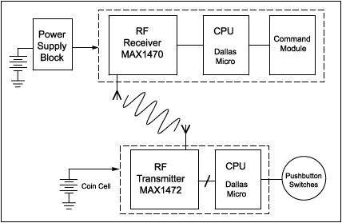

Fig . 3 . 1 Schematics of the keyless ignition system

The existing systems for intelligent two-wheelers vary depending on the anufacturer and model . However, some common features include:

1 . Smart sensors: These sensors are used to collect data about the vehicle's performance, including speed, temperature, and battery life . This data is then used to optimize the vehicle's performance and improve its efficiency .

2 . Connectivity: Many smart two-wheelers are connected to mobile devices and other IoT devices, allowing riders to access real-time information about their vehicle's performance and location .

3 . Anti-lock braking system (ABS): ABS is a safety feature that prevents the wheels from locking up during hard braking, reducing the risk of skidding and loss of control .

4 . Traction control: Traction control is a safety feature that helps prevent the wheels from slipping on wet or slippery surfaces, improving stability and control .

5 . Collision warning system: This system uses sensors and AI algorithms to detect potential collisions and alert the rider to take evasive action .

6 . Electric powertrain: Most smart two-wheelers use electric powertrains, which are more energy-efficient and emit fewer pollutants than traditional gasoline engines .

Overall, these features make smart two-wheelers safer, more efficient, and more connected than traditional vehicles . As technology continues to evolve, we can expect to see even more advanced features in future models .

A security system based on RFID, GPS and GSM [3] consolidate the establishment of an electronic gadget in a vehicle, with reason planned machine programming to empower the organization to track the vehicle's area . RFID is an acronym for “radio-frequency identification” and refers to a technology whereby digital data encoded in RFID tags or smart labels (defined below) are captured by a reader via radio waves . RFID is similar to barcoding . In that, data from a tag or label are captured by a device that stores the data in a database . At the point when the car picks the worker, he/she needs to swap the RFID card . RFID belongs to a group of technologies referred to as Automatic Identification and Data Capture (AIDC) . AIDC methods automatically identify objects, collect data about them, and enter those data directly into computer systems with little or no human intervention . RFID methods utilize radio waves to accomplish this . At a simple level, RFID systems consist of three components: an RFID tag or smart label, an RFID reader, and an antenna . RFID tags contain an integrated circuit and an antenna, which are used to transmit data to the RFID reader (also called as interrogator) . The reader then converts the radio waves into a more usable form of data . Information collected from the tags is then transferred through a communication interface to a host computer system, where the data can be stored in a database and analysed at a later time . The microcontroller matches the RFID card number with its database records and sends the representative's ID, taxi ID & the taxicab position co-ordinates to the organization unit by means of GSM module . The GSM module will get the message through GSM in the organization unit . On the off chance that worker ends up by himself/herself in an issue, he/she will press the catch button . Microcontroller will distinguish the activity and send a signal to the GSM will intimate the organization unit and the police .

**Disadvantages of RFID**

• Low security

• No theft detection

• Theft person can easily escape

• Theft person may hack the security system .

**CHAPTER 4**

### PROPOSED SYSTEM

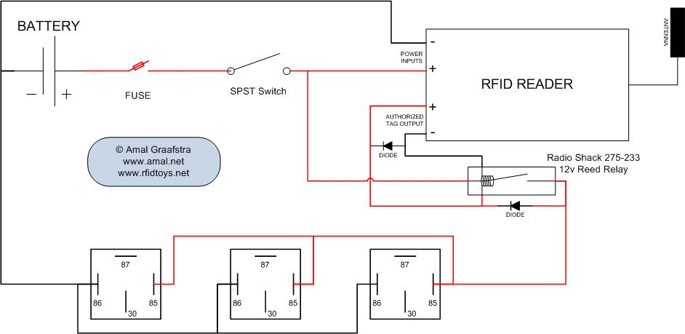

Fig . 4 . 1 The schematics of the RF based Motorcycle keyless ignition System

To the proposed system of smart two-wheeler intelligent bike is an innovative solution that aims to improve the safety, performance, and efficiency of two-wheelers . The system integrates advanced technologies like artificial intelligence, IoT, and sensors to provide real-time insights and control over the bike's functions . Here are some of the key features of the proposed system:

**4 . 1 . Intelligent Safety System:**

The system includes a range of sensors and cameras that monitor the bike's surroundings and detect potential hazards like obstacles, pedestrians, and other vehicles . The AI-powered safety system alerts the rider in case of any danger and takes corrective action to avoid accidents .

**4 . 2 . Smart Navigation:**

The system includes GPS and mapping technologies that provide real-time navigation and route optimization . The rider can set the destination on the app, and the system will guide them through the most efficient route .

**4 . 3 . Integrated Connectivity:**

The system is integrated with a mobile app that provides access to real-time data like speed, fuel level, battery status, and other bike parameters . The app also enables riders to connect with other riders and share their location .

**4 . 4 . Performance Optimization:**

The system uses advanced algorithms to optimize the bike's performance based on the rider's preferences and riding conditions . The AI-powered engine management system adjusts the throttle response, gear shifting, and other parameters to deliver the best performance and fuel efficiency .

**4 . 5 . Anti-Theft Protection:**

The system includes an anti-theft feature that uses GPS tracking to locate the bike in case of theft . The rider can also remotely disable the engine through the mobile app to prevent unauthorized access .

**4 . 6 . Overview :**

The proposed system of smart two-wheeler intelligent bike is a game-changer for the two-wheeler industry, providing riders with a safer, smarter, and more efficient riding experience .

The proposed BLUETOOTH-based tracking technique is divided into two main phases, namely the calibration of BLUETOOTH coefficients (deterministic phase) and the distance along with position estimation of user location by iterative trilateration (probabilistic phase) . A low complexity BLUETOOTH smoothing algorithm is implemented to minimize the dynamic fluctuation of radio signal received from each reference node when the target node is moving . Experimental measurements are carried out to analyse the sensitivity of BLUETOOTH . Whenever someone attempts to unlock the vehicle, the security components installed in the vehicle send a signal to the owner of the vehicle via GSM modem and BLUETOOTH . The owner then tries to establish connectivity with the security system in the vehicle through SMS from predefined number . Once the connectivity is established, the owner can choose one of the four actions like engine ignition cut off, fuel supply cut off, wheel lock and door lock as per his judgment in order to prevent the vehicle from theft .

**Advantages**

• Chances of theft will reduce .

• Theft person will be trapped inside

• Fast response

**CHAPTER 5**

**FLOWCHART EXPLANATION**

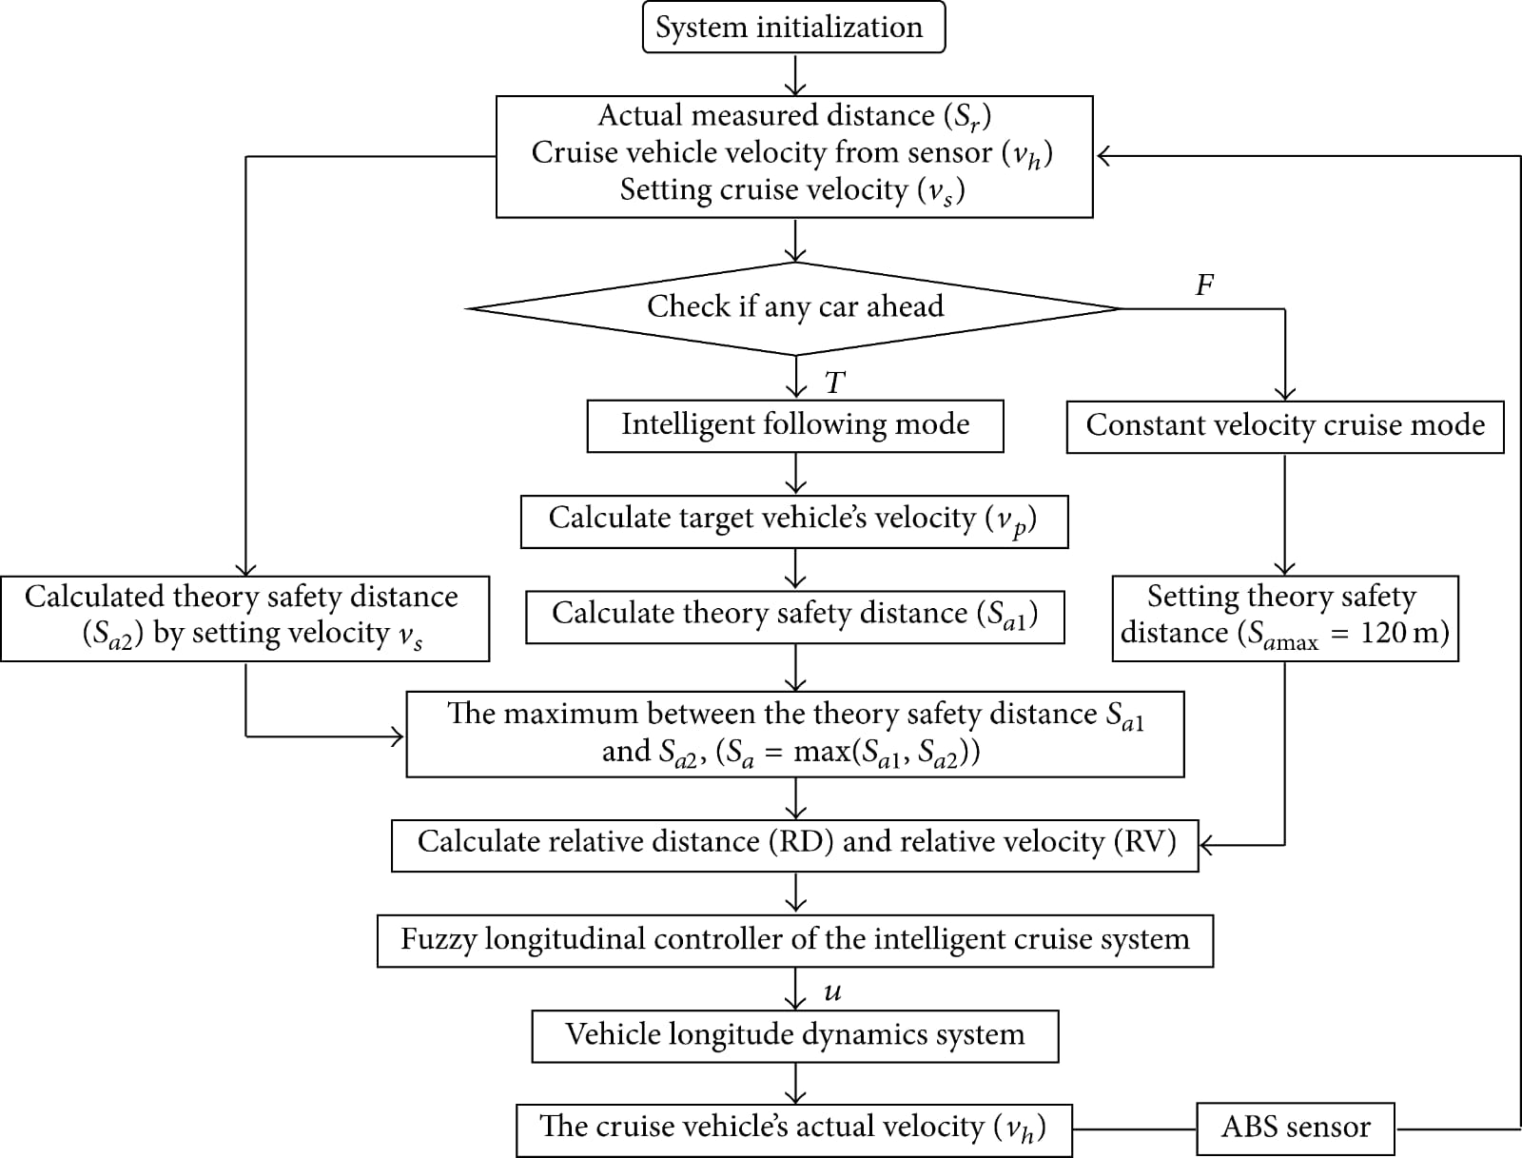

**5 . 1 FlowChart Of Keyless Ignition System**

#### 

**5 . 2 Block diagram Of keyless ignition System**

**CHAPTER 6**

### HARDWARE DESIGN

#### COMPONENTS USED

1. **Main Circuit** 
   1. **Voltage regulator**
   2. **RF Transceiver**
   3. **ESP32 DEV Board**
   4. **Vibration Sensor**
   5. **Relay**
   6. **DC-DC Step Down Converter Module LM2596**

**6 . 1 . Voltage regulator:**

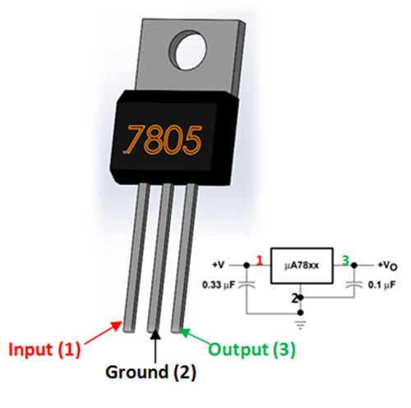

**6 . 1 . Voltage Regulator**

A voltage regulator is a circuit that creates and maintains a fixed output voltage, irrespective of changes to the input voltage or load conditions . Voltage regulators (VRs) keep the voltages from a power supply within a range that is compatible with the other electrical components .

While voltage regulators are most commonly used for DC/DC power conversion, some can perform AC/AC or AC/DC power conversion as well . This article will focus on DC/DC voltage regulators .

A voltage regulator is a system designed to automatically maintain a constant voltage . A voltage regulator may use a simple feed-forward design or may include negative feedback . It may use an electromechanical mechanism, or electronic components . Depending on the design, it may be used to regulate one or more AC or DC voltages . An integrated circuit voltage regulator

Electronic voltage regulators are found in devices such as computer power supplies where they stabilize the DC voltages used by the processor and other elements . In automobile alternators and central power station generator plants, voltage regulators control the output of the plant . In an electric power distribution system, voltage regulators may be installed at a substation or along distribution lines so that all customers receive steady voltage independent of how much power is drawn from the line .

**6 . 1 . 1 . Limitations of Voltage Regulators:**

One of the main disadvantages for linear regulators is that they can be inefficient, as they dissipate large amounts of power in certain use cases . The voltage drop of a linear regulator is comparable to a voltage drop across a resistor . For instance, with a 5V input voltage and a 3V output voltage, there is a 2V drop between the terminals, and the efficiency is limited to 3V/5V (60%) . This means linear regulators are best suited for applications with lower VIN / VOUT differentials . It is important to consider the estimated power dissipation of a linear regulator in application, since using larger input voltages results in high power dissipation that can overheat and damage components . Another limitation of linear voltage regulators is that they are only capable of buck (step-down) conversion, in contrast to switching regulators, which also offer boost (step-up) and buck-boost conversion . Switching regulators are highly efficient, but some disadvantages include that they are generally less cost-effective than linear regulators, larger in size, more complex, and can create more noise if their external components are not carefully selected . Noise can be very important for a given application, as noise can affect circuit operation and performance, as well as EMI performance .

**6 . 1 . 2 . Voltage Regulator Control:**

The four fundamental components of a linear regulator are a pass transistor, error amplifier, voltage reference, and resistor feedback network . One of the inputs to the error amplifier is set by two resistors (R1 and R2) to monitor a percentage of the output voltage . The other input is a stable voltage reference (VREF) . If the sampled output voltage changes relative to VREF, the error amplifier changes the pass transistor’s resistance to maintain a constant output voltage (VOUT) . Linear regulators typically only require an external input and output capacitor to operate, making them easy to implement . On the other hand, a switching regulator requires more components to create the circuit . The power stage switches between VIN and ground to create charge packets to deliver to the output . Similar to a linear regulator, there is an operational amplifier that samples the DC output voltage from the feedback network and compares it to an internal voltage reference . Then the error signal is amplified, compensated, and filtered . This signal is used to modulate the PWM duty cycle to pull the output back into regulation . The Arduino Nano is a small, complete, and breadboard-friendly board based on the ATmega328P released in 2008 . It offers the same connectivity and specs of the Arduino Uno board in a smaller form factor .

**6 . 2 . REMOTE KEYLESS SYSTEM:**



**6 . 2 . Fig . Of Remote keyless System**

A remote keyless system (RKS), also known as remote keyless entry (RKE) or remote central locking, is an electronic lock that controls access to a building or vehicle by using an electronic remote control (activated by a handheld device or automatically by proximity) . RKS largely and quickly superseded keyless entry, a budding technology that restrictively bound locking and locking functions to vehicle-mounted keypads .

Widely used in automobiles, an RKS performs the functions of a standard car key without physical contact . When within a few yards of the car, pressing a button on the remote can lock or unlock the doors, and may perform other functions .

A remote keyless system can include both remote keyless entry (RKE), which unlocks the doors, and remote keyless ignition (RKI), which starts the engine .

Remote keyless entry was patented in 1981 by Paul Lipschultz, who worked for Niemans (a supplier of security components to the car industry) and had developed a number of automotive security devices . His electrically actuated lock system could be controlled by using a handheld fob to stream infrared data . Patented in 1981 after successful submission in 1979, it worked using a "coded pulse signal generator and battery-powered infra-red radiation emitter . " In some geographic areas, the system is called a PLIP system, or Plipper, after Lipschultz . Infrared technology was superseded in 1995 when a European frequency was standardised .

The remote keyless systems using a handheld transmitter first appeared on the French made Renault Fuego in 1982,and as an option on several American Motors vehicles in 1983, including the Renault Alliance . The feature gained its first widespread availability in the U . S . on several General Motors vehicles in 1989 ,Keyless remotes contain a short-range radio transmitter, and must be within a certain range, usually 5–20 meters, of the car to work .

When a button is pushed, it sends a coded signal by radio waves to a receiver unit in the car, which locks or unlocks the door . Most RKEs operate at a frequency of 315 MHz for North America-made cars and at 433 . 92 MHz for European, Japanese and Asian cars . Modern systems since the mid-1990s implement encryption as well as rotating entry codes to prevent car thieves from intercepting and spoofing the signal . Earlier systems used infrared instead of radio signals to unlock the vehicle, such as systems found on Mercedes-Benz, BMW and other manufacturers . The system signals that it has either locked or unlocked the car usually through some fairly discreet combination of flashing vehicle lamps, a distinctive sound other than the horn, or some usage of the horn itself .

A typical setup on cars is to have the horn or other sound chirp twice to signify that the car has been unlocked, and chirp once to indicate the car has been locked . For example, Toyota, Scion, and Lexus use a chirp system to signify the car being locked/unlocked . While two beeps means that driver's door is unlocked, four beeps means all doors are unlocked . One long beep is for the trunk or power tailgate .

One short beep signifies that the car is locked and alarm is set . The functions of a remote keyless entry system are contained on a key fob or built into the ignition key handle itself . Buttons are dedicated to locking or unlocking the doors and opening the trunk or tailgate . On some minivans, the power sliding doors can be opened/closed remotely . Some cars will also close any open windows and roof when remotely locking the car . Some remote keyless fobs also feature a red panic button which activates the car alarm as a standard feature .

Further adding to the convenience, some cars' engines with remote keyless ignition systems can be started by the push of a button on the key fob (useful in cold weather), and convertible tops can be raised and lowered from outside the vehicle while it's parked .

On cars where the trunk release is electronically operated, it can be triggered to open by a button on the remote . Conventionally, the trunk springs open with the help of hydraulic struts or torsion springs, and thereafter must be lowered manually .

Premium models, such as SUVs and estates with tailgates, may have a motorized assist that can both open and close the tailgate for easy access and remote operation . For offices, or residences, the system can also be coupled with the security system, garage door opener or remotely activated lighting devices . Remote keyless entry fobs emit a radio frequency with a designated, distinct digital identity code . Inasmuch as "programming" fobs is a proprietary technical process, it is typically performed by the automobile manufacturer . In general, the procedure is to put the car computer in 'programming mode' . This usually entails engaging the power in the car several times while holding a button or lever . It may also include opening doors, or removing fuses .

The procedure varies amongst various makes, models, and years . Once in 'programming mode' one or more of the fob buttons is depressed to send the digital identity code to the car's onboard computer . The computer saves the code and the car is then taken out of programming mode .

As RKS fobs have become more prevalent in the automobile industry a secondary market of unprogrammed devices has sprung up . Some websites sell steps to program fobs for individual models of cars as well as accessory kits to remotely activate other car devices .

On early (1998–2012) keyless entry remotes, the remotes can be individually programmed by the user, by pressing a button on the remote, and starting the vehicle . However, newer (2013+) keyless entry remotes require dealership or locksmith programming via a computer with special software .

The Infrared keyless entry systems offered user programming, though radio frequency keyless entry systems mostly require dealer programming .

**6.3. KEYLESS IGNITION SYSTEM:**

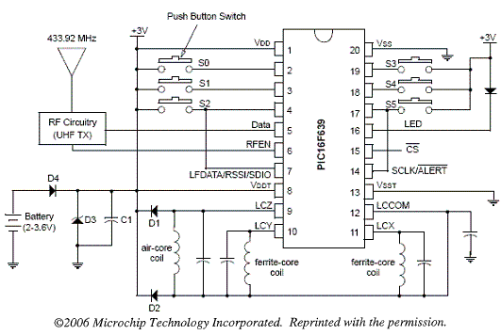

**6.3. Fig. Of keyless ignition System**

Some cars have a proximity system that is triggered if a transponder car key is within a certain distance of the car and is sometimes called hands-free or advanced key . One of the earliest systems was found on the 1993 Chevrolet Corvette (called the Passive Keyless Entry System) and in Mercedes-Benz vehicles from 1998 . Today, this system is commonly found on a variety of vehicles, and although the exact method of operation differs between makes and models, their operation is generally similar: a vehicle can be unlocked without the driver needing to physically push a button on the key fob to lock or unlock the car and is also able to start or stop the ignition without physically having to insert the key and turning the ignition . Instead, the vehicle senses that the key (which may be located in the user's pocket, purse, etc . ) is approaching the vehicle . A simpler version of the smart key system is the engine immobiliser, involving a security key system embedded into most modern vehicle's keys . A small chip rests on the vehicle's key or under the plastic key cover .

When any key is inserted into the ignition, the ignition is coded . The key sends its security code to the ignition, which also has its own security code, and if the security codes match, the vehicle will start when the key is turned .

However, if the key codes do NOT match, the vehicle will NOT start when the key is turned . Some early examples of this technology include Chrysler Corporation's Sentry Key System, or General Motors's PASSKey System .

Some security keys can be programmed by the user, though most of these keys have to be programmed by a dealership or locksmith via a computer . It was not possible to copy these keys at a hardware store or auto parts store, but nowadays it is .

Keyless ignition does not by default provide better security . In October 2014, it was found that some insurers in the United Kingdom would not insure certain vehicles with keyless ignition unless there were additional mechanical locks in place due to weaknesses in the keyless system .

A security concern with any remote entry system is a spoofing technique called a replay attack, in which a thief records the signal sent by the key fob using a specialized receiver called a code grabber, and later replays it to open the door . To prevent this, the key fob does not use the same unlock code each time but a rolling code system; it contains a pseudorandom number generator which transmits a different code each use .

The car's receiver has another pseudorandom number generator synchronized to the fob to recognise the code . To prevent a thief from simulating the pseudorandom number generator the fob encrypts the code .

News media have reported cases where it is suspected that criminals managed to open cars by using signal boosters to trick vehicles into thinking that their keyless entry fobs were close by even when they were far away (relay attack),though they have not reported that any such devices have been found . The articles speculate that keeping fobs in aluminum foil or a freezer when not in use can prevent criminals from exploiting this vulnerability .

In 2015, it was reported that Samy Kamkar had built an inexpensive electronic device about the size of a wallet that could be concealed on or near a locked vehicle to capture a single keyless entry code to be used at a later time to unlock the vehicle .

The device transmits a jamming signal to block the vehicle's reception of rolling code signals from the owner's fob, while recording these signals from both of his two attempts needed to unlock the vehicle .

The recorded first code is sent to the vehicle only when the owner makes the second attempt, while the recorded second code is retained for future use . Kamkar stated that this vulnerability had been widely known for years to be present in many vehicle types but was previously undemonstrated .

Actual thefts targeting luxury cars based on the above exploit have been reported when the key fob is near the front of the home . Several workaround can prevent such exploits, including placing the key fob in a tin box . A criminal ring stole about 100 vehicles using this technique in Southern and Eastern Ontario . An ignition switch, starter switch or start switch is a switch in the control system of a motor vehicle that activates the main electrical systems for the vehicle, including "accessories" (radio, power windows, etc . ) .

In vehicles powered by internal combustion engines, the switch provides power to the starter solenoid and the ignition system components (including the engine control unit and ignition coil), and is frequently combined with the starter switch which activates the starter motor

. Historically, ignition switches were key switches that requires the proper key to be inserted in order for the switch functions to be unlocked . These mechanical switches remain common in modern vehicles, further combined with an immobiliser to only activate the switch functions when a transponder signal in the key is detected . However, many new vehicles have been equipped with so-called "keyless" systems, which replace the key switch with a push button that also requires a transponder signal .

The ignition locking system may be sometimes bypassed by disconnecting the wiring to the switch and manipulating it directly; this is known as hotwiring . Ignition switches are generally a simple repair that can be completed without much knowledge . They are mainly vehicle specific and plug and play .

**6.4. RF TRANSCEIVER:**

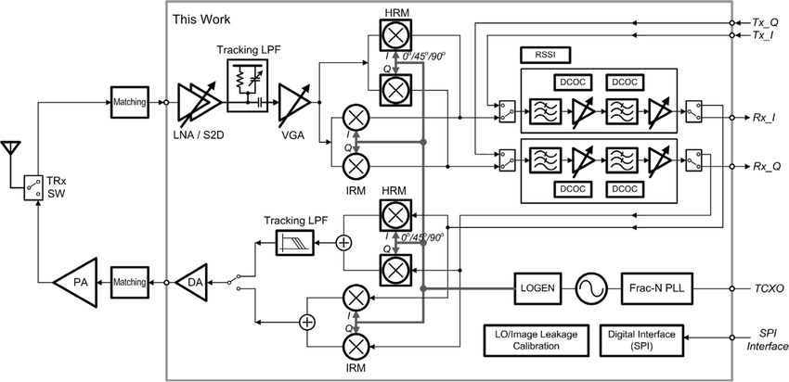

**6.4. Fig . Of Radio Frequency Transmission**

**6.4.1. The Working Principle of RF Transceivers**

RF transceivers consist of an antenna and a tuner . The antenna receives transmitted signals while the tuner separates them .

To send signals, an RF amplifier is used to boost the signal strength out of the antenna for better range . The antenna then takes this signal and converts it into electromagnetic waves . These EM waves travel through the receiver’s antenna . The receiver’s antenna will then modify the incoming signals back into the current . This process is reversed when sending information back to its originator .

Detectors or demodulators extract information that was encoded before transmission . Radio techniques are also used to limit localised interference and noise . Moreover, oscillators come in handy when transmitting a new signal . They create sine waves, encoded and broadcast as radio signals .

Overall, RF transceivers form the link between two devices within communication networks . Without them, wireless communications would be virtually impossible .

**6.4.2. Technical Specifications**

Specifications of RF transceivers include the following:

Data rate . The number of bits per second that can be transmitted . Sensitivity . The minimum input signal required . Output power . The power produced into a 50 Ohm load connected at the radio antenna port . Communication interface . The method used to output data to computers . Operating frequency . The range of signals that can be broadcast and received . Measurement resolution . The minimum digital resolution .

Maximum transmission distance . The largest distance by which the transmitter and receiver can be separated .

There are many parameters related to RF transceivers to add . First, on the transmitter part, the parameters include the following:

• Gain flatness

• Gain adjustment

• i/p and o/p frequency range

• Conversion gain

• Compression point

• 1dBm frequency stability

• Spurious and harmonic o/p

Whereas the parameters on the receiver part come with the following:

• i/p and o/p frequency range

• Gain flatness

• Gain adjustment

• Spurious output

• Noise figure

• Image rejection

• Adjacent channel

• Nonadjacent channel

• Rejection frequency stability

RF Transceivers Common Applications:

RF transceivers are used in wireless communication . Their main application is to make information in the form of data/voice/video apt . They also alter IF frequency to RF frequency and vice versa .

**Common wireless communication applications include:**

• Radio transmission

• Satellite communication

• Television signal transmission

• Reception

• Wimax or WLAN, Zigbee, or ITE networks

**Others:**

**6.4.3. RF-based home automation system**

This design features a home automation system controlled by an RF remote . It allows modern houses to shift from conventional switches to centralised control systems .

Thus the loads can be turned ON/OFF remotely using the RF remote . It sends ON/OFF commands to the receiver end, where loads are connected .

Abbreviations used:

RF . Radio frequency .

kHz . Kilohertz . It is a unit of measurement of radio waves equal to 1,000 hertz .

GHz . Short for gigahertz . It is a unit of frequency equal to one billion hertz .

EM . Electromagnetic waves . Waves are created from vibrations between an electric field and a magnetic field .

I/P and O/P . Input and output .

Choosing RF Transceivers

When selecting RF transceivers, you need to understand these modulations and techniques:

Amplitude modulation (AM) . It causes the baseband signal to vary the amplitude or height of the carrier wave . Then, it creates the desired information content .

Frequency modulation (FM) . It encodes information in a carrier wave by varying its instantaneous frequency .

The ON/OFF key (OOK) . The simplest form of modulation consists of turning the signal ON and OFF .

Amplitude shift key (ASK) . Transmits data by varying the amplitude of the transmitted signal .

Frequency shift key (FSK) . A digital modulation scheme using two or more o/p frequencies .

Phase shift key (PSK) . A technique in which the baseband data signal varies the transmitted signal’s phase .

As for radio techniques, some RF transceivers use a direct-sequence spread spectrum . Others utilise the frequency-hopping spread spectrum .

As an AI language model, I don't have the ability to create diagrams, but I can explain the working principle of RF transmission . RF transmission refers to the process of transmitting radio frequency signals wirelessly over a distance .

The working principle of RF transmission involves the use of a transmitter and a receiver . The transmitter converts the electrical signal into a radio frequency signal and sends it through an antenna . The receiver picks up the signal using its own antenna and converts it back into an electrical signal .

The RF signal travels through the air at the speed of light and can be affected by various environmental factors such as obstacles, distance, and interference from other devices operating on the same frequency .

In order to ensure reliable communication, the transmitter and receiver must be tuned to the same frequency and use a protocol that allows for error correction and data encoding . RF transmission is widely used in various applications such as wireless communication, remote control systems, and GPS navigation systems

**6.5. ESP32 DEV BOARD:**

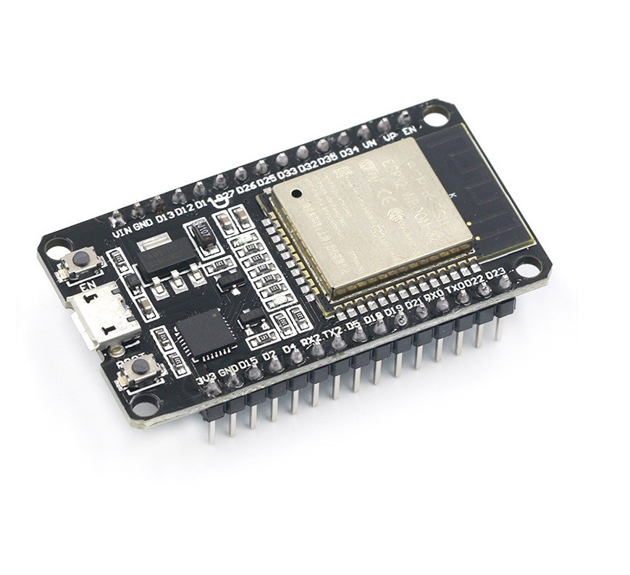

**6.5. Fig. Of ESP32 DEV Board**

The ESP32 is a series of low-cost and low-power System on a Chip (SoC) microcontrollers developed by Espressif that include Wi-Fi and Bluetooth wireless capabilities and dual-core processor . If you’re familiar with the ESP8266, the ESP32 is its successor, loaded with lots of new features .

Compatible with MicroPython: you can program the ESP32 with MicroPython firmware, which is a re-implementation of Python 3 targeted for microcontrollers and embedded systems .

**6.5.1. ESP32 Specifications:**

If you want to get a bit more technical and specific, you can take a look at the following detailed specifications of the ESP32

• peripheral interface with DMA that includes capacitive touch

• ADCs (Analog-to-Digital Converter)

• DACs (Digital-to-Analog Converter)

• I²C (Inter-Integrated Circuit)

• UART (Universal Asynchronous Receiver/Transmitter)

• SPI (Serial Peripheral Interface)

• I²S (Integrated Interchip Sound)

• RMII (Reduced Media-Independent Interface)

• PWM (Pulse-Width Modulation)

• Security: hardware accelerators for AES and SSL/TLS

The ESP32 is faster than the ESP8266;

The ESP32 comes with more GPIOs with multiple functions;

The ESP32 supports analog measurements on 18 channels (analog-enabled pins)

versus just one 10-bit ADC pin on the ESP8266

The ESP32 supports Bluetooth while the ESP8266 doesn’t;

The ESP32 is dual-core (most models), and the ESP8266 is single core;

The ESP32 is a bit more expensive than the ESP8266 .

**6.5.2. ESP32 Development Boards**

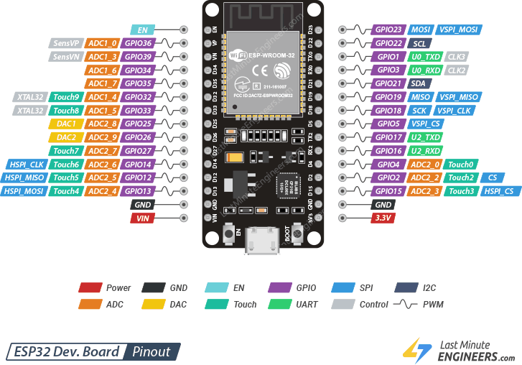

ESP32 refers to the bare ESP32 chip . However, the “ESP32” term is also used to refer to ESP32 development boards . Using ESP32 bare chips is not easy or practical, especially when learning, testing, and prototyping . Most of the time, you’ll want to use an ESP32 development board .

These development boards come with all the needed circuitry to power and program the chip, connect it to your computer, pins to connect peripherals, built-in power and control LEDs, an antenna for wi-fi signal, and other useful features . Others even come with extra hardware like specific sensors or modules, displays, or a camera in the case of the ESP32-CAM .

Once you start searching for ESP32 boards online, you’ll find there is a wide variety of boards from different vendors . While they all work in a similar way, some boards may be more suitable for some projects than others . When looking for an ESP32 development board there are several aspects you need to take into account .

USB-to-UART interface and voltage regulator circuit . Most full-featured development boards have these two features . This is important to easily connect the ESP32 to your computer to upload code and apply power .

BOOT and RESET/EN buttons to put the board in flashing mode or reset (restart) the board . Some boards don’t have the BOOT button . Usually, these boards go into flashing mode automatically .

Pin configuration and the number of pins . To properly use the ESP32 in your projects, you need to have access to the board pinout (like a map that shows which pin corresponds to which GPIO and its features) .   
 So make sure you have access to the pinout of the board you’re getting . Otherwise, you may end up using the ESP32 incorrectly .

Antenna connector . Most boards come with an onboard antenna for Wi-Fi signal . Some boards come with an antenna connector to optionally connect an external antenna . Adding an external antenna increases your Wi-Fi range .

Battery connector . If you want to power your ESP32 using batteries, there are development boards that come with connectors for LiPo batteries—this can be handier . You can also power a “regular” ESP32 with batteries through the power pins .

Extra hardware features . There are ESP32 development boards with extra hardware features . For example, some may come with a built-in OLED display, a LoRa module, a SIM800 module (for GSM and GPRS), a battery holder, a camera, or others .

For beginners, we recommend an ESP32 board with a vast selection of available GPIOs, and without any extra hardware features . It’s also important that it comes with voltage regular and USB input for power and upload code .

In most of our ESP32 projects, we use the ESP32 DEVKIT DOIT board, and that’s the one we recommend for beginners .

There are different versions of this board with a different number of available pins (30, 36, and 38)—all boards work in a similar way .

**6.5.3. ESP32 DEVKIT:**

In this article, we’ll be using the ESP32 DEVKIT DOIT board as a reference . If you have a different board, don’t worry . The information on this page is also compatible with other ESP32 development boards .

The picture below shows the ESP32 DEVKIT DOIT V1 board, version with 36 GPIO pins .

ESP32 GPIOs Pinout Guide

The ESP32 chip comes with 48 pins with multiple functions . Not all pins are exposed in all ESP32 development boards, and some pins should not be used . The ESP32 DEVKIT V1 DOIT board usually comes with 36 exposed GPIOs that you can use to connect peripherals .

Power Pins

Usually, all boards come with power pins: 3V3, GND, and VIN . You can use these pins to power the board (if you’re not providing power through the USB port), or to get power for other peripherals (if you’re powering the board using the USB port) .

General Purpose Input Output Pins (GPIOS)

Almost all GPIOs have a number assigned and that’s how you should refer to them—by their number .

With the ESP32 you can decide which pins are UART, I2C, or SPI – you just need to set that on the code . This is possible due to the ESP32 chip’s multiplexing feature that allows to assign multiple functions to the same pin .

If you don’t set them on the code, the pins will be configured by default as shown in the figure below (the pin location can change depending on the manufacturer) . Additionally, there are pins with specific features that make them suitable or not for a particular project .

**6.5.4. ESP32 DEVKIT V1 Pins Pinout**

We have a detailed guide dedicated to the ESP32 GPIOs that we recommend you read: ESP32 Pinout Reference Guide . It shows how to use the ESP32 GPIOs and explains what are the best GPIOs to use depending on your project .

The placement of the GPIOs might be different depending on your board model . However, usually, each specific GPIO works in the same way regardless of the development board you’re using (with some exceptions) .

For example, regardless of the board, usually GPIO5 is always the VSPI CS0 pin, GPIO 23 always corresponds to VSPI MOSI for SPI communication, etc .

**6.6. RELAY :**

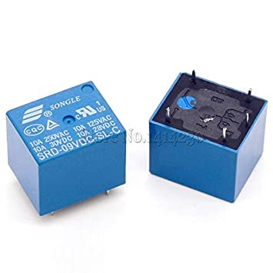

**6.5. Fig. Of Relay**

Another important hardware used here is relay . The 5V relay module can be used to control a load such as a lighting system, motor, or solenoid . It can also be used to switch AC or DC voltages .

The maximum voltage and current that the 5V relay module can control is dependent on the specifications of the relay .

A 5V relay module is a single or multi-channel relay module that works with a low-level trigger voltage of 5V DC . The input voltage can be from any microcontroller or logic chip that outputs a digital signal .

Like most other relays, the 5V relay module is an electrically operated, electromagnetic switch that can be used to turn on or turn off a circuit . It consists of two parts: the relay itself and the control module .

The relay contains the coil that creates the magnetic field, the armature that move to complete or disconnect a circuit, and contacts that open and close to operate the load switch .

The relay control module is the interface or part of the relay module that the user interacts with . It contains the input terminals for connecting to the microcontroller, as well as the output terminals for connecting to the load .

The control module also contains LED indicators for power and status and other devices such as protection diode, transistor, resistor, and other semiconductor devices necessary for its operation .

**6.6.1. 5V Relay Module Specifications:**

The 5V relay module specifications are normally written on the top side . These include the input voltage/current, load current/voltage, and operating or release times . The specifications vary depending on the manufacturer .

In general, they would look something like this:

Normal voltage: 5V DC

Normal current: 70mA

Maximum load current: 10A/250V AC, 10A/30V DC

Maximum switch voltage: 250V AC, 30V DC

Operate time: ≤ 10ms

Release time: ≤ 5ms

**6.6.2.5V Relay Module Circuit**

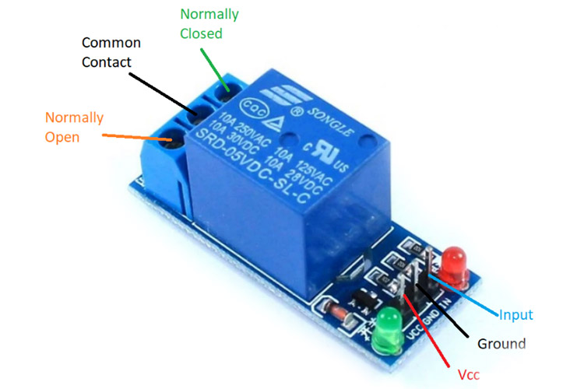

**6.6.2. Fig. Of 5V Relay**

The 5V relay modules are made up of connection points or pins, and several major components, such as diodes, transistors, resistors, and the relay itself .

These make up the circuit that controls the relay . The 5V relay module circuit is further explained below .

**6.6.3. 5V Relay Module Pinout**

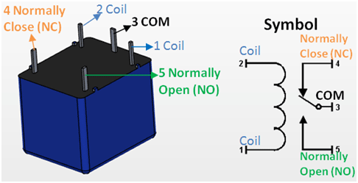

**6.6.3. Fig. Of 5V Relay module PINOUT**

The 5V relay module pinout is composed of connections on the input side where it receives the trigger signal, and the output side where it controls the load .

The input side, as shown in the above relay module circuit diagram, has 3 or 4 connections: These are listed and explained below .

VCC – this is the power connection . It supplies 5V DC to the module and is normally connected to the positive terminal of the power supply .

GND – this is the ground connection . It connects to the negative terminal of the power supply .

IN1, IN2 – these are the inputs where the trigger signal is applied . IN1 is for a single-channel relay module, while IN2 is for a dual-channel relay module . The IN (Input) pin is connected to the output of the microcontroller, sensor, or logic device .

The relay module output side has three connections:

NO (Normally Open) – this is the load connection when the relay is ON . When the relay is off, the NO maintains an open connection with the COM .

COM (Common) – The relay module connection labeled “COM” is the common connection for both the NO and NC (Normally Closed) pins .

NC (Normally Closed) – this is the load connection . It connects to the COM terminal by default, or when the relay is OFF .

5V Relay Module Parts

Now, let’s take a look at the main components of a 5V relay module . They include

The LED – this is an indicator or status LED that lights up when the relay is ON .

The transistor – the transistor amplifies the trigger signal so that it can activate the relay .

The diode – a flyback diode is used to protect the 5V relay module circuit from flyback voltage spikes when the relay coil de-energizes .

The resistor – the resistor limits the current flowing through the relay module circuit .

The relay – this is the main switching component of the module and usually either an NC (Normally Closed) or NO (Normally Open) type .

**6.6.4. 5V Relay Module Working**

The 5V relay module requires a 5V signal delivered from a microcontroller or sensor to trigger the switch . Its working is also very simple . When the input pin is HIGH, the relay turns on, and when the input is LOW it turns off . Below is the 5V relay module working principle .

The relay is activated by a low-level trigger signal applied to its IN1 or IN2 pin . When the trigger signal is applied, the transistor turns ON and amplifies the signal .

This triggers the relay to turn ON and connect the load to either the NO or NC pin . The LED will light up to indicate that the relay is ON .

When the trigger signal is removed, the transistor turns OFF and the relay turns OFF . The load is then disconnected from the NO or NC pin . The LED will turn OFF to indicate that the relay is OFF .

The 5V relay module can be used to control a load such as a lighting system, motor, or solenoid . It can also be used to switch AC or DC voltages . The maximum voltage and current that the 5V relay module can control is dependent on the specifications of the relay .

**6.6.5. 5V Relay Module for Arduino**

The 5V relay module can be easily interfaced with an Arduino . The above diagram shows how to connect a single-channel relay module with Arduino microcontrollers, a popular project among hobbyists . The 5V relay module Arduino wiring is very simple:

You only need to connect the VCC and GND pins of the relay module to the 5V and GND pins of the Arduino, connect the IN1 pin of the relay module to a digital output pin of the Arduino, and connect the load to the NO and COM pins of the relay module .

When the digital output pin is set to HIGH, the module turns ON and activates the relay . This will turn ON the load connected to the NO and COM pins of the relay module .

When the digital output pin is set to LOW, the circuit OFF and deactivates the relay, turning OFF the load .

The 5V relay module can also be easily interfaced with a Raspberry Pi . When used with a Raspberry Pi, 5V relay module can be used to control a load such as an LED system, motor, or solenoid .

The 5V relay module is a very handy tool for switching electric loads and power systems . What’s more, you can interface with an array of microcontrollers, including Arduino or Raspberry Pi, as well as other logic devices . The 5V relay module can also be used to switch AC or DC voltages . Just be sure to check the specifications of the relay to ensure that it can handle the voltage and current of your load .

**6.7. Vibration sensor:**

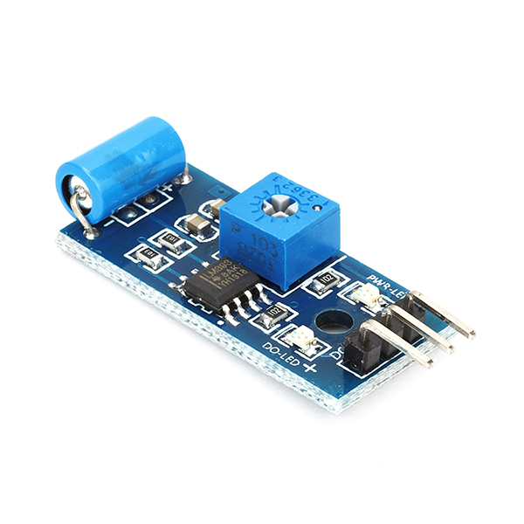

**6.7. Fig, Of vibration sensor**

• Unauthorised access of a car with the help of duplicate key,so vibration sensor activates and buzzer rings .

• The vibration sensor is also called a piezoelectric sensor . These sensors are flexible devices which are used for measuring various processes and uses the piezoelectric effects

while measuring the changes within acceleration, pressure, temperature, force otherwise strain by changing to an electrical charge .

Vibration sensor module based on the vibration sensor SW-420 and Comparator . LM393 is used to detect if there is any vibration beyond the threshold level . Threshold can adjust using an onboard potentiometer .

When there is no vibration detected, the sensor provides logic LOW and when the vibration is detected, the sensor provides logic HIGH .

A vibration sensor SW-20 NC type is a sensor that detects vibrations and is of the normally closed (NC) type .

This means that when there is no vibration, the circuit is closed and current can flow through it . When there is vibration, the circuit opens and interrupts the current flow .

This type of sensor is commonly used in security systems to detect movement or tampering, and can also be used in industrial applications to monitor machinery for vibrations that could indicate a problem or failure .

**6.8. DC-DC STEP DOWN CONVERTER MODULE LM2596:**

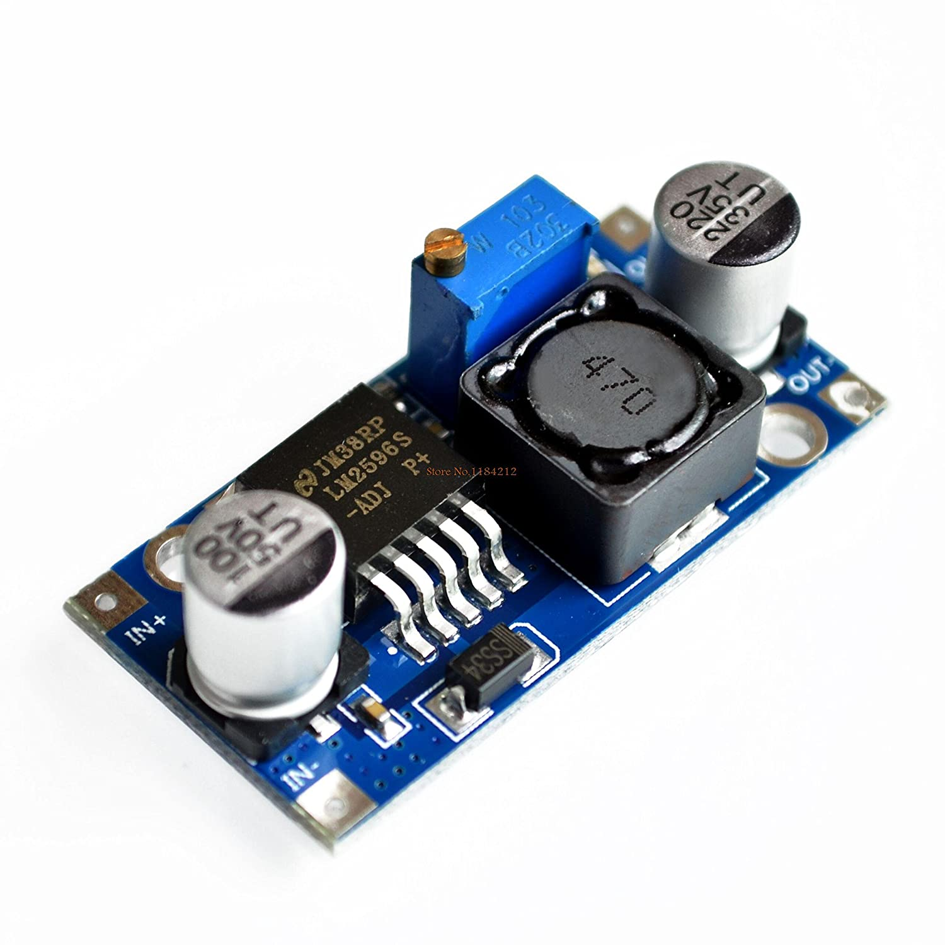

**6.8. Fig. Of LM2596 Step Down Converter**

The LM2596 series of regulators are monolithic integrated circuits that provide all the active functions for a step-down (buck) switching regulator, capable of driving a 3-A load with excellent line and load regulation . These devices are available in fixed output voltages of 3 . 3 V, 5 V, 12 V, and an adjustable output version . Requiring a minimum number of external components, these regulators are simple to use and include internal frequency compensation, and a fixed-frequency oscillator .

The LM2596 series operates at a switching frequency of 150 kHz, thus allowing smaller sized filter components than what can be required with lower frequency switching regulators . Available in a standard 5-pin TO-220 package with several different lead bend options, and a 5-pin TO-263 surface mount package .

A standard series of inductors are available from several different manufacturers optimized for use with the LM2596 series . This feature greatly simplifies the design of switch-mode power supplies .

Other features include a ±4% tolerance on output voltage under specified input voltage and output load conditions, and ±15% on the oscillator frequency . External shutdown is included, featuring typically 80 μA standby current . Self-protection features include a two stage frequency reducing current limit for the output switch and an overtemperature shutdown for complete protection under fault conditions .

The **LM2596** is a commonly used popular **step-down switching regulator IC** . The adjustable version can take in input voltage from 4 . 5V to 40V and convert it to variable voltage sourcing upto of 3A of continues current . Because of its high current capability is commonly used in power modules to power/control heavy loads .

**6.8.1. PIN CONFIGURATIONS AND FUNCTIONS:**

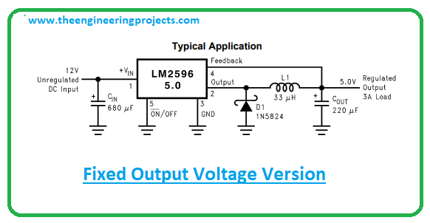

**6.8.1. Pin Configuration And functions of LM2596**

The LM2596 SIMPLE SWITCHER® power converter regulator is an easy-to-use, nonsynchronous, step-down DC-DC converter with a wide input voltage range up to 40 V . The regulator is capable of delivering up to 3-A DC load current with excellent line and load regulation . These devices are available in fixed output voltages of 3 . 3-V, 5-V, 12-V, and an adjustable output version . The family requires few external components, and the pin arrangement was designed for simple, optimum PCB layout .

The circuit in Figure 8-1 uses the ON/OFF pin to provide a time delay between the time the input voltage is applied and the time the output voltage comes up (only the circuitry pertaining to the delayed start-up is shown) . As the input voltage rises, the charging of capacitor C1 pulls the ON/OFF pin high, keeping the regulator OFF .

After the input voltage reaches its final value and the capacitor stops charging, resistor R2 pulls the ON/OFF pin low, thus allowing the circuit to start switching . Resistor R1 is included to limit the maximum voltage applied to the ON/OFF pin (maximum of 25 V), reduces power supply noise sensitivity, and also limits the capacitor C1 discharge current . When high input ripple voltage exists, avoid long delay time, because this ripple can be coupled into the ON/OFF pin and cause problems . This delayed start-up feature is useful in situations where the input power source is limited in the amount of current it can deliver . It allows the input voltage to rise to a higher voltage before the regulator starts operating . Buck regulators require less input current at higher input voltages . Some applications require the regulator to remain off until the input voltage reaches a predetermined voltage . apply the same feature to an inverting circuit . The circuit features a constant threshold voltage for turnon and turnoff (Zener voltage plus approximately one volt) . If hysteresis is required, the circuit has a turnon voltage which is different than the turnoff voltage . The amount of hysteresis is approximately equal to the value of the output voltage . If Zener voltages greater than 25 V are used, an additional 47-kΩ resistor is required from the ON/OFF pin to the ground pin to stay within the 25 V maximum limit of the ON/OFF pin .

The circuit converts a positive input voltage to a negative output voltage with a common ground . The circuit operates by bootstrapping the ground pin of the regulator to the negative output voltage, then grounding the feedback pin, the regulator senses the inverted output voltage and regulates it . This circuit has an ON/OFF threshold of approximately 13 V .

**6.8.2. Undervoltage Lockout for Inverting Regulator**

This example uses the LM2596-5 . 0 to generate a −5-V output, but other output voltages are possible by selecting other output voltage versions, including the adjustable version . Because this regulator topology can produce an output voltage that is either greater than or less than the input voltage, the maximum output current greatly depends on both the input and output voltage . It provides a guide as to the amount of output load current possible for the different input and output voltage conditions . The maximum voltage appearing across the regulator is the absolute sum of the input and output voltage, and this must be limited to a maximum of 40 V . For example, when converting +20 V to −12 V, the regulator can see 32 V between the input pin and ground pin . The LM2596 has a maximum input voltage spec of 40 V .

Additional diodes are required in this regulator configuration . Diode D1 is used to isolate input voltage ripple or noise from coupling through the CIN capacitor to the output, under light or no load conditions . Also, this diode isolation changes the topology to closely resemble a buck configuration, thus providing good closed-loop stability . TI recommends using a Schottky diode for low input voltages, (because of its lower voltage drop) but for higher input voltages, a fast recovery diode can be used . Without diode D3, when the input voltage is first applied, the charging current of CIN can pull the output positive by several volts for a short period of time . Adding D3 prevents the output from going positive by more than a diode voltage .

The output pin (switch) waveform can have some damped sinusoidal ringing present . This ringing is normal for discontinuous operation, and is not caused by feedback loop instabilities .

In discontinuous operation, there is a period of time where neither the switch nor the diode are conducting, and the inductor current has dropped to zero . During this time, a small amount of energy can circulate between the inductor and the switch/diode parasitic capacitance causing this characteristic ringing .

Normally this ringing is not a problem, unless the amplitude becomes great enough to exceed the input voltage, and even then, there is very little energy present to cause damage .

Different inductor types or core materials produce different amounts of this characteristic ringing . Ferrite core inductors have very little core loss and therefore produce the most ringing . The higher core loss of powdered iron inductors produce less ringing . If desired, a series RC can be placed in parallel with the inductor to dampen the ringing .

The selection guide chooses inductor values suitable for continuous mode operation, but for low current applications or high input voltages, a discontinuous mode design can be a better choice .

A discontinuous mode design can use an inductor that can be physically smaller, and can require only one half to one third the inductance value required for a continuous mode design .

The peak switch and inductor currents will be higher in a discontinuous design, but at these low load currents (1 A and below), the maximum switch current will still be less than the switch current limit .

**6.8.3 PIN 12 V RELAY:**

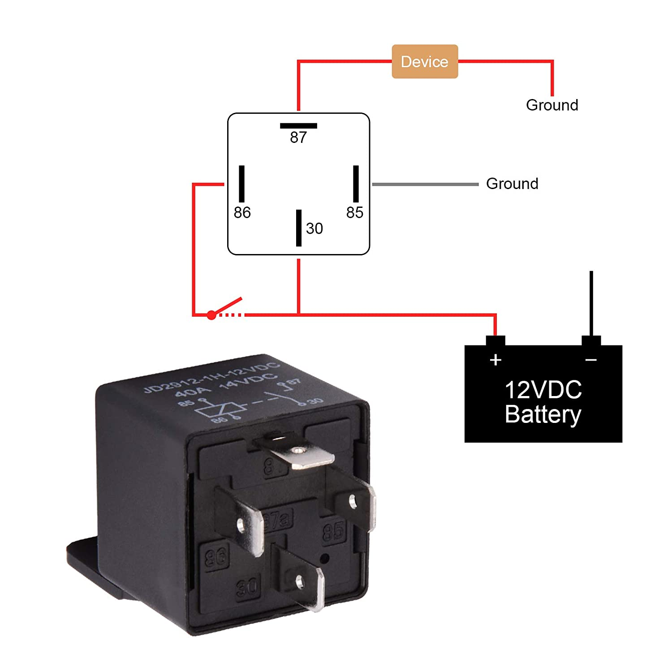

**6.9. Fig. Of 12V 4 Pin Relay**

A 4 pin 12V relay is an electronic switch that is used to control electrical circuits by turning them on or off . It has four pins or terminals that are used for different functions:

1 . Coil terminal - This is the terminal that receives the 12V power supply to energize the relay coil .

2 . Normally open (NO) terminal - This is the terminal that is connected to the electrical circuit that needs to be controlled . When the relay is energized, this terminal closes and allows current to flow through the circuit .

3 . Normally closed (NC) terminal - This is the terminal that is connected to the electrical circuit when the relay is not energized . When the relay is energized, this terminal opens and interrupts the current flow through the circuit .

4 . Common terminal - This is the terminal that is used to connect the NO and NC terminals to the power supply .

A 4 pin 12V relay can be used in a variety of applications, such as automotive electronics, industrial control systems, and home automation .

**CHAPTER 7**

### CONCLUSION

In this project, we made detailed go thorough learning on a mixture of different components of kit circuits is obtainable in an effective manner . The technologies projected under every group has been finished and presented here in a successful manner . In order to figure out, an immense lesson was complete the growth of kit circuits in all dimensions as well as right through the time, smart kit system circuits has been evolved .

Experiments and new technology components has been proposed and tested . Smart kit circuit significant information was noted and a smart device that creates talented outcome of the results in prevents accidents by monitoring various conditions . We observed that same information applied on a quantity of cases, various algorithms creates entirely different results . The foremost complexity faced by kit system is choosing a suitable conceptual algorithm that would superior suit the accident free and lighter version .

A uncomplicated readily obtainable well known Arduino uno nothing but microcontroller always choosed by scientist, educators and researches for use of smart design . The final outcome of the literature is safe and secure travel between source to destination . Developed smart kit system is a valuable answer to numerous troubles . Compulsory condition to start a two-wheeler bike was wearing the component kit and also human being clear head which in turn reducing the probability of road accidents .

The proposed smart kit device maintenance the two-wheeler driver and create safer roads because it acts as a virtual policeman . The device Smart kit using radio frequency is price valuable and beneficial methodologies . The smart kit device method ensures the security of the two-wheeler rider by wearing the component of kit . Adjacent located hospital, road transfort officiers, and members available in their family are being conveyed regarding two wheeler accidents . Automatic documentation, identification, and statement the accident immediately with very high accuracy has been done with the help of accident detection algorithm .

### REFERENCES

[1] StamosKatsigiannis , Rhys Willis, and NaeemRamzan, (2019), “A QoE and Simulator Sickness Evaluation of a Smart-Exercise-Bike Virtual Reality System via User Feedback and Physiological Signals”,IEEE Transactions On Consumer Electronics, 65(1),119-127 .

[2] Sayanee Nanda, Harshada Joshi and SmitaKhairnar,(2018), “An IOT Based Smart System for Accident Prevention and Detection”, Fourth International Conference on Computing Communication Control and Automation (ICCUBEA), 1(1), 1-6 .

[3] Divyasudha N, Arulmozhivarman P and Rajkumar E, (2019), “Analysis of Smart kits and Designing an IoT based smart kit: A cost effective solution for Riders”, 1st International Conference on Innovation in Information and Communication Technology (ICIICT), 1(1), 1-4 . [4] Jesudoss A, Vybhavi R and Anusha B, (2019), “Design of Smart Kit for Accident Avoidance”, International Conference on Communication and Signal Processing, 1(1), 0774-0778 .

[5] Durga K Prasad Gudavalli, Bh . Sudha Rani and C . Vidyasagar, (2017), “Kit Operated Smart E-Bike”, IEEE International Conference On Intelligent Techniques In Control, Optimization And Signal Processing, 1(1), 1-5 .

[6] RashmiVashisth, Sanchit Gupta, Aditya Jain, Sarthak Gupta, Sahil, PrashantRana, (2017), “Implementation And Analysis Of Smart Kit”, 4th IEEE International Conference on Signal Processing, Computing and Control (ISPCC 2k17), 1(1), 111-117 . ]

[7] Shikha Gupta, Kashish Sharma, NiharSalvekar and AkshayGajra , (2019), “Implementation of Alcohol and Collision Sensors in a Smart Kit”, International Conference on Nascent Technologies in Engineering (ICNTE 2019), 1(1), 1-5 .

[8] Md . AtiqurRahman, S . M Ahsanuzzaman, IshmanRahman, (2020), “IoT Based Smart Kit and Accident Identification System”, IEEE Region 10 Symposium (TENSYMP), 1(1), 14-17 .

[9] ApoorvaSaumya, Gayathri . V, Dr . Venkateswaran K, Sarthak Kale, Dr . Sridhar N, (2020), “Machine Learning based Surveillance System for Detection of Bike Riders without Kit and Triple Rides”, Proceedings of the International Conference on Smart Electronics and Communication (ICOSEC 2020), 1(1), 347-352 .

[10] S . J . Swathi, Shubham Raj and D . Devaraj, (2019), “Microcontroller and Sensor Based Smart Biking System for Driver’s Safety”, IEEE International Conference on Intelligent Techniques in Control, Optimization and Signal Processing (INCOS), 1(1), 1-5 .

[11] Megha H . N and R . H . Goudar, (2017), “ Next Generation Intelligent Traffic Management System and analysis for Smart Cities”, International Conference On Smart Technologies For Smart Nation (SmartTechCon), 1(1), -999-1003 .

[12] Valanukonda Lakshmi Padmini, G . Krishna Kishore, PonnuruDurgamalleswarao, (2020), “Real Time Automatic Detection of Motorcyclists With and Without a Safety Kit”, Proceedings of the International Conference on Smart Electronics and Communication (ICOSEC 2020),1(1), 1251-1256 .

[13] DangetiAnuPreetham ,MukundalaSaiRohit, Arun . G . Ghontale, M . Jasmine PemeenaPriyadarsini, (2017), “Safety Kit With Alcohol Detection And Theft Control For Bikers”, Proceedings of the International Conference on Intelligent Sustainable Systems (ICISS 2017),1(1), 668-673 .

[14] SreehariKarthikeyan, Shivank Singh, Himanshu M Jain, M . Sailesh Kumar, Ms . Vishnu Priya, (2018), “Smart and Assistive Driving Headgear”, Proceedings of the International Conference on Communication and Electronics Systems (ICCES 2018), 1(1), 335-339 .

[15] Nataraja N, Mamatha K S, Dr . Keshavamurthy and Dr . Shivashankar, (2018), “Smart Kit” 3rd IEEE International Conference on Recent Trends in Electronics, Information & Communication Technology (RTEICT-2018), 1(1), 2338-2341 .

[16] Dinesh Singh, C . Vishnu and C . Krishna Mohan, (2016), Visual Big Data Analytics for Traffic Monitoring in Smart City”, 15th IEEE International Conference on Machine Learning and Applications, 1(1), 886-891 .

[17] Nitin Agarwal, Anshul Kumar Singh ,(2015), “Smart Kit”, International Research Journal of Engineering and Technology”

### APPENDIX

#### Code for the Prototype

#include <BleKeyboard . h>

#define volup 12

#define voldown 13

#define play 14

#define next 27

#define prev 26

BleKeyboard bleKeyboard;

void setup() {

pinMode(volup, INPUT_PULLUP);

pinMode(voldown, INPUT_PULLUP);

pinMode(play, INPUT_PULLUP);

pinMode(next, INPUT_PULLUP);

pinMode(prev, INPUT_PULLUP);

Serial . begin(115200);

Serial . println("Starting BLE work!");

bleKeyboard . begin();

}

void loop() {

if(bleKeyboard . isConnected()) {

if(digitalRead(volup)== LOW){

Serial . println("VOLUME UP");

bleKeyboard . write(KEY_MEDIA_VOLUME_UP);

delay(500);

}

else if(digitalRead(voldown)== LOW){

Serial . println("VOLUME DOWN");

bleKeyboard . write(KEY_MEDIA_VOLUME_DOWN);

delay(500);

}

else if(digitalRead(play)== LOW){

Serial . println("PLAY or PAUSE the music");

bleKeyboard . write(KEY_MEDIA_PLAY_PAUSE);

delay(500);

}

else if(digitalRead(next)== LOW){

Serial . println("Next track");

bleKeyboard . write(KEY_MEDIA_NEXT_TRACK);

delay(500);

}

else if(digitalRead(prev)== LOW){

Serial . println("previous track ");

bleKeyboard . write(KEY_MEDIA_PREVIOUS_TRACK);

delay(500);

}

}

}

#include <BLEDevice . h>

#include <Arduino . h>

#include <BLEUtils . h>

#include <BLEScan . h>

#include <BLEAdvertisedDevice . h>

#include <BLEEddystoneURL . h>

#include <BLEEddystoneTLM . h>

#include <BLEBeacon . h>

#define ADDRESS "ff:ff:10:79:5a:0a"

#define UUID "6b27b72c-9fdd-beb9-9f41-579ef9e81b82"

#define UUID2 "85eae855-eba2-478a-2b46-20112810c08a"

#define ENDIAN_CHANGE_U16(x) ((((x)&0xFF00) >> 8) + (((x)&0xFF) << 8))

#define RELAY_PIN 13

#define SCAN_INTERVAL 1000

#define TARGET_RSSI -85

#define MAX_MISSING_TIME 7000

BLEScan* pBLEScan;

unsigned long lastScanTime = 0;

boolean found = false;

unsigned long lastFoundTime = 0;

int rssi = 0;

class MyAdvertisedDeviceCallbacks: public BLEAdvertisedDeviceCallbacks

{

void onResult(BLEAdvertisedDevice advertisedDevice)

{

std::string strManufacturerData = advertisedDevice . getManufacturerData();

uint8_t cManufacturerData[100];

strManufacturerData . copy((char *)cManufacturerData, strManufacturerData . length(), 0);

Serial . print("Device found: ");

Serial . println(advertisedDevice . toString() . c_str());

rssi = advertisedDevice . getRSSI();

Serial . println("RSSI: ");

Serial . println(rssi);

BLEBeacon oBeacon = BLEBeacon();

oBeacon . setData(strManufacturerData);

Serial . printf("iBeacon Frame\n");

Serial . printf("ID: %04X Major: %d Minor: %d UUID: %s Power: %d\n", oBeacon . getManufacturerId(), ENDIAN_CHANGE_U16(oBeacon . getMajor()), ENDIAN_CHANGE_U16(oBeacon . getMinor()), oBeacon . getProximityUUID() . toString() . c_str(), oBeacon . getSignalPower());

if(advertisedDevice . getAddress() . toString() == ADDRESS||oBeacon . getProximityUUID() . toString() == UUID||oBeacon . getProximityUUID() . toString() == UUID2)

{

found = true;

advertisedDevice . getScan()->stop();

}

}

} ;

void setup()

{

Serial . begin(115200);

pinMode(RELAY_PIN, OUTPUT);

digitalWrite(RELAY_PIN, LOW);

BLEDevice::init("");

pBLEScan = BLEDevice::getScan();

pBLEScan->setAdvertisedDeviceCallbacks(new MyAdvertisedDeviceCallbacks());

pBLEScan->setActiveScan(true);

BLEScanResults foundDevices;

// Serial . print("Found gadgets: ");

Serial . println(foundDevices . getCount());

}

void loop()

{

unsigned long now = millis();

if(found){

found = false;

if(rssi > TARGET_RSSI){

lastFoundTime = millis();

digitalWrite(RELAY_PIN, HIGH);

lastFoundTime = now;

}

}

else if(now - lastFoundTime > MAX_MISSING_TIME){

digitalWrite(RELAY_PIN, LOW);

}

if(now - lastScanTime > SCAN_INTERVAL){

lastScanTime = now;

pBLEScan->start(1);

}

}